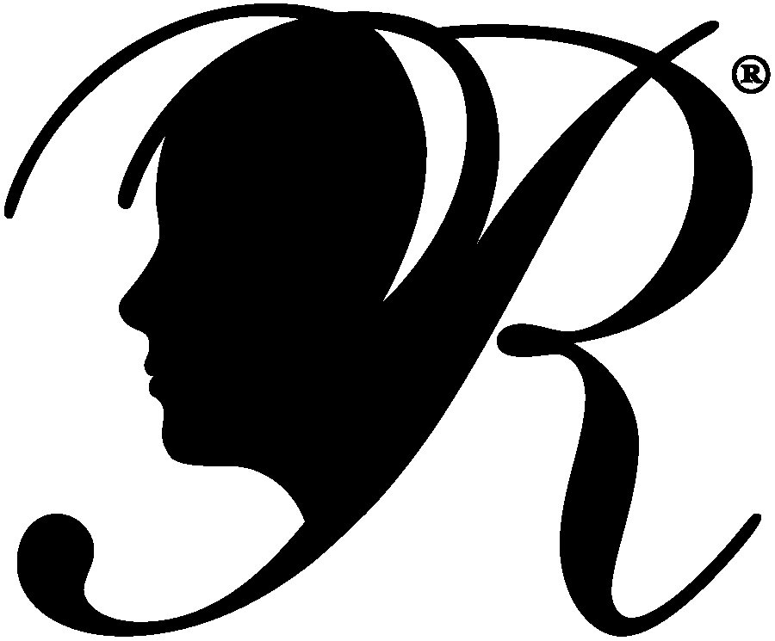

Special Artist

# **Deadline is <<>> 3:30 PM**

1. Download the Student Entry Form from our website at [**<<WEBSITE >>>**](http://pointdefiancepta.org/reflections.php)
2. Read the rules for the corresponding category to make sure that all rules are followed. Rules are on the WA PTA website at <https://www.wastatepta.org/events-programs/reflections/>
3. Complete the Student Entry Form and don’t forget to get a parent’s signature. Your entry will be returned if there is NO PARENT SIGNATURE.
4. Drop your entries and work in the box labeled Reflections in the main office.
5. If you have questions, please email me at [**<<EMAIL>>**](mailto:menaka.abraham@gmail.com)
6. Selected entries will move to the Council level. Entries selected from Council level will move to State level. You will be notified if your entry moves to the next level. Make sure that your parent’s email address is on the entry form and is legible to get notification.

The Reflections Program is a National PTA and WSPTA cultural arts competition. The purpose is to provide an opportunity for students to use their creative talents by expressing themselves through their own original works.

What is Reflections?

Reflections   
Theme: Within Reach

### Entry Categories

Prizes for participation and also special celebration for the class with the most entries!

Dance Choreography

Visual Arts

Photography

Music Composition

Literature

Film Production